AI-ASSISTANT CODING
ASSIGNMENT-13.1

Bandam Akarsh
2303A53018
BATCH_46

Task Description #1 (Refactoring – Removing Code Duplication)

Code:
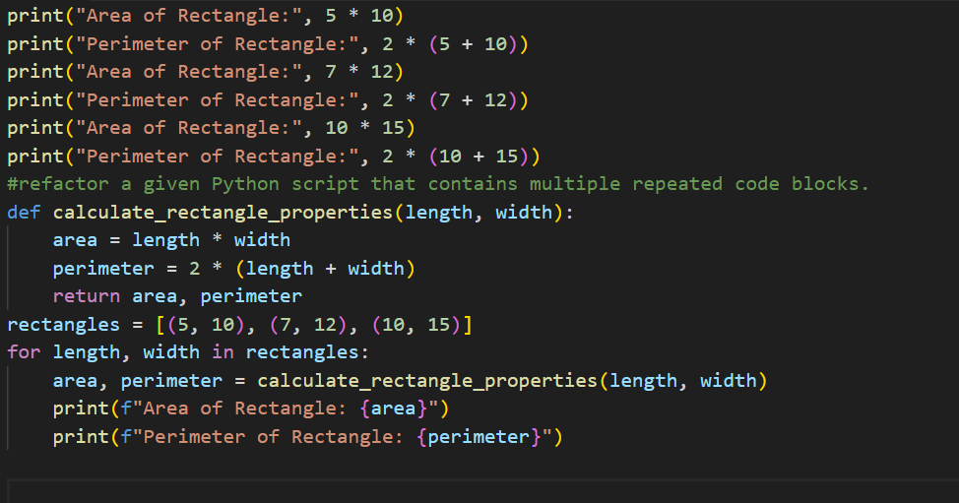

Output:
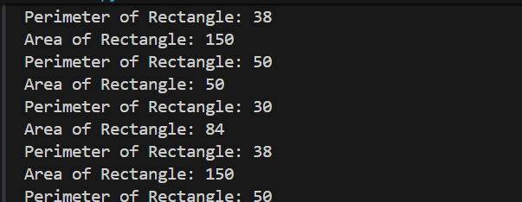

Task Description #2 (Refactoring – Optimizing Loops and Conditionals)

Prompt:

Code:
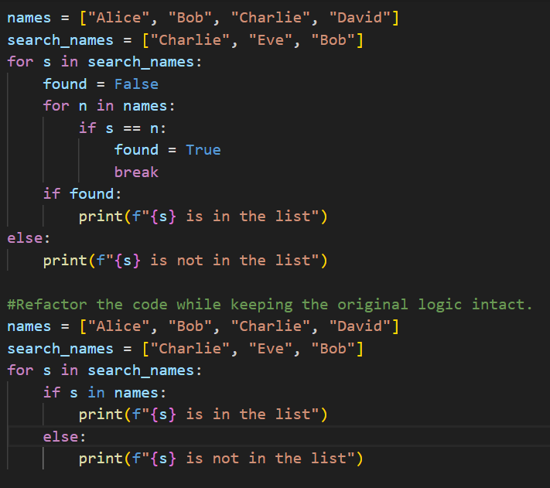

Output:
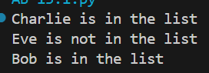

Task Description #3 (Refactoring – Extracting Reusable Functions)

Prompt:

Code:
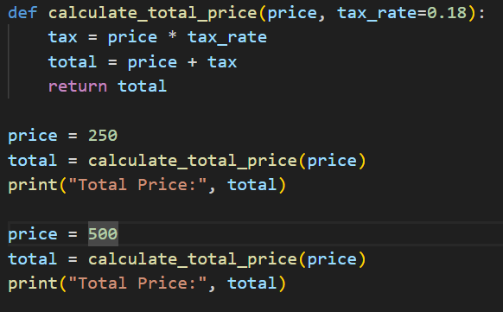

Output:
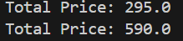
Task Description #4 (Refactoring – Replacing Hardcoded Values with Constants)
Prompt:

Code:
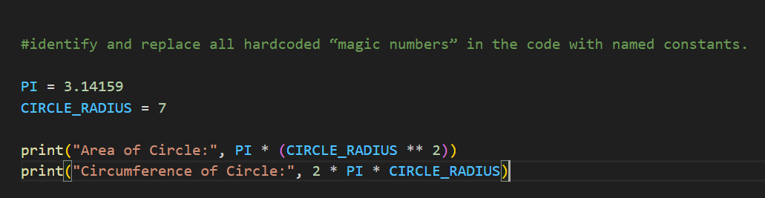

Output:
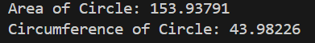
Task Description #5 (Refactoring – Improving Variable Naming and Readability)
Prompt:

Code:

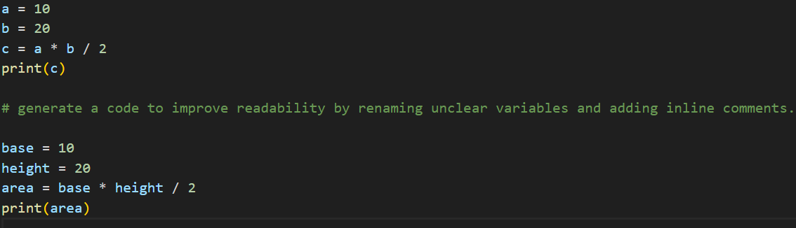
Output:

